**TRINITY INTERNATIONAL SS & COLLEGE**

**Dillibazar Height, Kathmandu, Nepal**



**LAB WORK # 4: Application Package (MS-Excel)**

**(COMPUTER SCIENCE)**

**SUBMITTED BY: SUBMITTED TO:**

**NAME: Prashim Timsina**

**GRADE: XI (MC1)**

**DATE : [2079/08/16] PRAVEEN KOIRALA**

**Faculty of Computer Science**

**KATHMANDU, NEPAL**

**2022 Table of Contents**

S. No. Page No.

1. Acknowledgement I

2. Objectives II

3. Table of Contents III

4. Theoretical Background (1)

4.1 Application Package

4.1.1 What-If analysis

4.1.2 VLOOKUP Function

4.1.3 HLOOKUP Function

4.1.4 Result Sheet

5. Work Done

5.1 Students Result Sheet 2

5.2 VLOOKUP Function 2

5.3 HLOOKUP Function 3

5.4 What-If analysis 3

6. Conclusion

7. Bibliography

8. Appendix

**2. Objective**

The main objectives of the lab work are as follows:

1. To perform what-if analysis using goal seek and scenario manager.
2. To understand and apply VLOOKUP AND HLOOKUP.
3. To Practice preparing result sheet of student.

**3. Theoretical Background**

What if Analysis: It is the process of changing the values in cells to see how those changes will affect the outcome of formulas on thee worksheet.

VLOOKUP Function: It is used when you need to find things in a table or a range by row. For example, look up a price of an automotive part by the part number, or find an employee name based on their employee ID.

Its syntax is,

=VLOOKUP(What you want to look up, where you want to look for it, the column number in the range containing the value to return, return an Approximate or Exact match – indicated as 1/TRUE, or 0/FALSE).

HLOOKUP Function: It Searches for a value in the top row of a table or an array of values, and then returns a value in the same column from a row you specify in the table or array.

Its syntax is,

=HLOOKUP(What you want to look up, where you want to look for it, the row number in the range containing the value to return, return an Approximate or Exact match – indicated as 1/TRUE, or 0/FALSE).

Result sheet: Result sheet of students is a piece of data about the performance record of a students in terminal or internal examinations.

Page: 1

**4. Work Done**

1) Students Result Sheet

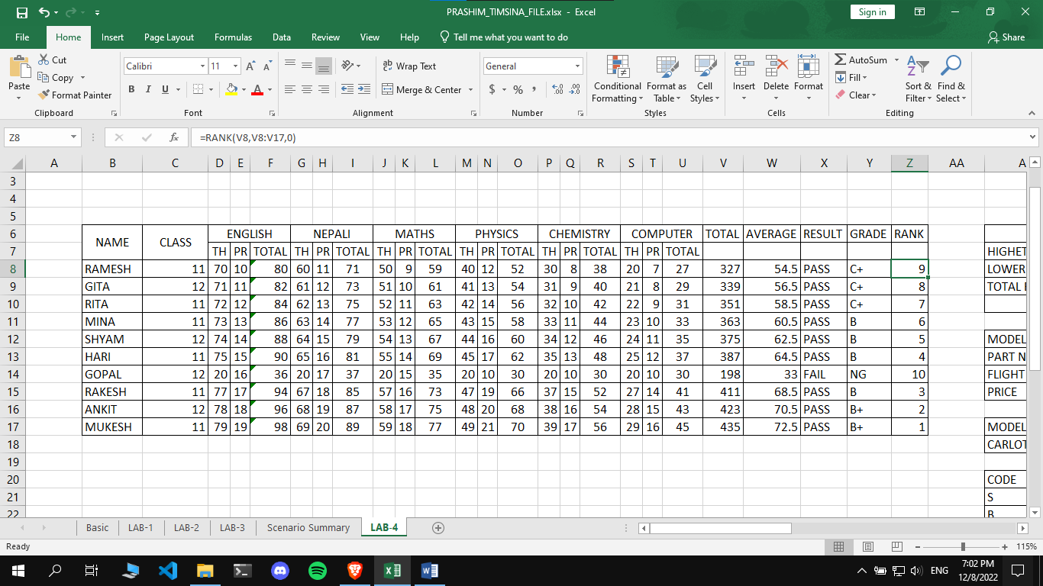

2) VLOOKUP Function

VLOOKUP Function can be accessed by using =VLOOKUP parameters

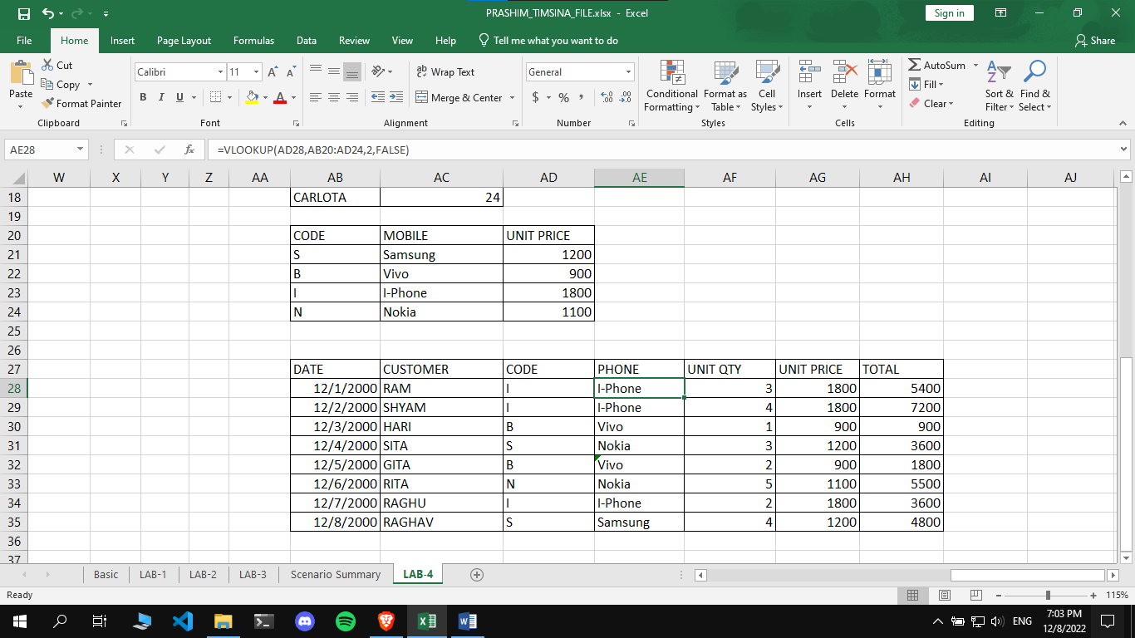

Page: 2

3) HLOOKUP Function

HLOOKUP Function can be triggered by using =HLOOKUP parameters.

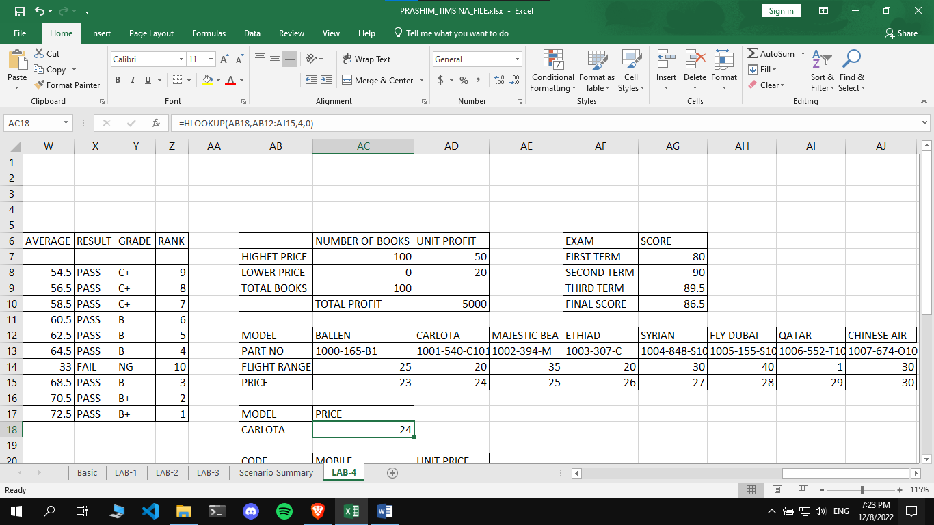

4) Goal Seek Manager

You can access goal seek manager in the data tab at the top left corner.

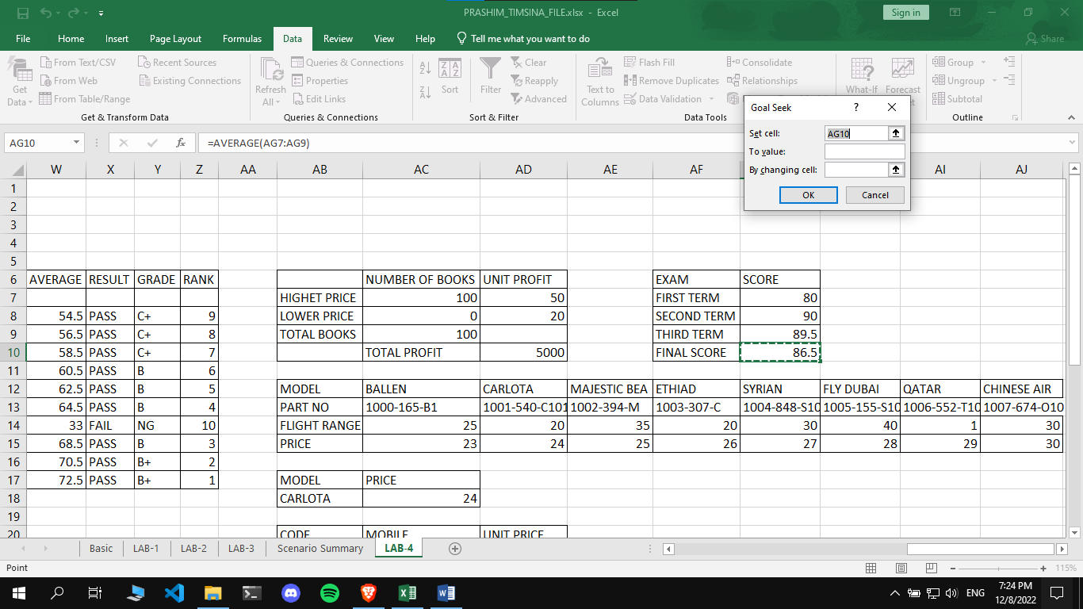

Page: 3

Page: 4